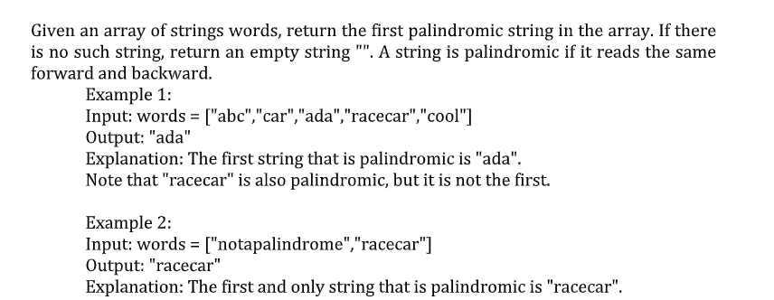

Program :
#include <stdio.h>
#include <string.h>
int isPalindrome(char word[]){
int i, len;
len = strlen(word);
for (i = 0; i < len / 2; i++){
if (word[i] != word[len - i - 1]){
return 0;
}
}
return 1;
}
int main(){
int n, i;
char words[100][100];
printf("Enter number of strings: ");
scanf("%d", &n);
printf("Enter the strings:\n");
for (i = 0; i < n; i++){
scanf("%s", words[i]);
}
for (i = 0; i < n; i++){
if (isPalindrome(words[i])){
printf("First palindrome: %s", words[i]);
return 0;
}
}
printf("No palindrome found");
return 0;
}
Input:
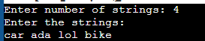
Output:

